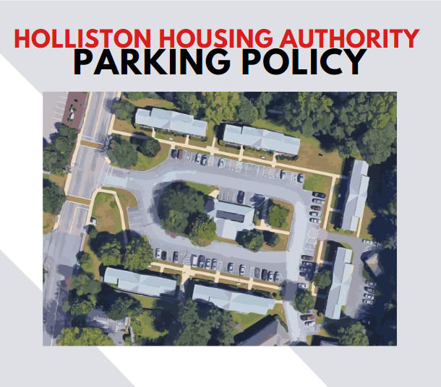

Holliston Housing Authority Parking Policy
Background
To manage the parking spaces in the Holliston Housing Authority Cole Court parking lot, Holliston Housing Authority has established the following policies and procedures:

- At all HHA Public Housing Community Parking Lots, the HHA may designate by markings and or signs allowable uses for the spaces in the lots. Designations may include, but are not limited to, Tenant Parking, Visitor Parking, HHA Staff Parking, Handicap Parking, and No Parking.

- Parking in any HHA lot is solely at Owners Risk. The use of any parking area is solely at vehicle owners’ risk, and the Holliston Housing Authority assumes no responsibility of any with respect to the vehicle or its contents; this provision shall not be waived by any action of the Holliston Housing Authority or its employees.

Parking Policy
- Residents must have a parking permit issued by the HHA to park in the HHA Cole Court parking lots and spaces. Parking permit(s) must be renewed at the time of recertification. [Failure to renew parking permit will result in removal of the vehicle after 10 calendar days of the effective recertification.]

- Residents must submit a “Parking Permit Application” for each vehicle before parking in any community spaces. Guests must park in “Visitors” spots. Notify the Housing Manager if a resident needs a replacement permit; there is no charge for replacement permits.

- Vehicles are limited to one (1) per Resident with a valid driver’s license with a maximum of two (2) vehicles per household. Vehicles must be owned by Resident with current registration, license, and valid driver’s license.

- Residents will abide by all applicable laws regarding ownership of a vehicle on HHA property. If Resident is found by the Massachusetts DMV to be incapable of driving, the vehicle must be removed from HHA property within 15 calendar days.

- There are no assigned spots in the Cole Court parking lot. Tenants may use the spaces in the Cole Court parking lot on a first come basis. Tenants parking in the parking lot must have an active parking permit from HHA, active drivers’ license, and car registration.

- To register a vehicle with HHA, residents are required to provide a copy of an active driver's license and vehicle registration.

- Handicap spots are filled on a first come basis with a valid handicap placard or plate. Please remember, pickups and drop offs in handicap spaces are also prohibited without a placard or plate.

- Parking permits must ALWAYS be visible and are not transferable from one vehicle to another.

- Residents must notify HHA within 1 business day when license number or ownership status changes.

- Vehicles may only park in designated/marked spaces, one (1) space per vehicle. Oversized vehicles that do not completely fit in 1 space are prohibited.

- Vehicles are not allowed to park on grass or lawn, in a fire lane, blocking a dumpster, or any other area that is not a clearly designated parking spot. in courtyards between buildings (this includes motorcycles) or drive on sidewalks.

- Non-operable vehicles will not be allowed to be kept in the HHA parking areas. Residents will have seven (7) calendar days to remove vehicle or have it repaired. A request for special consideration may be made to the Housing Manager with an attached repair schedule for review. Non-operable vehicles will be towed at tenant’s expense.

- Residents must immediately (within 1 business day) notify Housing Manager:

  - When license plate number is changed
  - When vehicle is no longer owned by Resident or Household member.
  - When resident first obtain vehicle that is to be parked on HHA property.

- HHA reserves the right to remove a vehicle from a parking area at the owner’ expense if a parking permit has been revoked, expired, or vehicle is in a designated spot without authorization.

- Vehicles must not leak fluids on the pavement such as oil or gasoline. If vehicles do leak fluids, the Resident will be responsible for the cleanup of the fluids and any cost incurred by the HHA in cleanup of fluids, including pavement repair.

- Only vehicles that are driven on a regular basis, year-round (at least twice monthly) will be issued a parking permit. A written request for special may be made to the Housing Manager for review. Due to limited parking spaces, it is not the intent to provide vehicle storage in the community parking spaces.

- Unless given a temporary pass, service providers should park in “Visitors Parking” spaces. This would be a person who assists residents by providing housekeeping, laundry services, shopping, and other household requirements.

- The only emergency repairs that may be conducted in the parking areas are changing flat tires, battery replacement, and windshield glass repair. No other repairs are allowed on HHA property.

- No washing of vehicles on HHA property.

- Unauthorized/improper parked vehicles (blocking access, yellow curbing, fire lanes, blocking dumpster, etc.) are subjected to ticketing and or removal by towing at the owner’s expense.

- Any vehicle may be removed by the HHA without prior notice to the Resident in emergency situations.

Snow / Weather / Construction:
Residents must be prepared to move their cars when a major weather event is anticipated. This might include snow removal operations or flooding from a hurricane. A snow Emergency Declaration by the Town of Holliston should warn Residents that restrictions are likely to be imposed by the Holliston Housing Authority
The Holliston Housing Authority will make every effort when conditions allow to notify residents by posting notices in first floor hallways. The Holliston Housing Authority reserves the right during major snowstorms to request vehicles be moved to a snow cleared location for purposes of snow removal. Failure to move vehicles during a major snowstorm may result in vehicle being towed due to health and safety.
Residents are to remove snow from their vehicles within 24 hours after the end of a storm to visibly display their parking permit, as well as to return vehicles back to legal parking spaces when they become available.
Construction
During periods of construction, residents must be prepared to cooperate with our efforts to improve our communities. As construction progresses, areas will be posted in advance of restriction by flyer. Cars parked in a posted area will be towed at the expense of the owner. If an emergency condition arises and does not allow for proper notification to be given, and we are unable to contact the owner of the vehicle, the vehicle will be “moved” to another area.
Placement of Permit
Automotive: The permit, in the form of a sticker, must be permanently affixed to the inside lower corner on the driver side (left side) of the vehicle’s back windshield (labeled Position A on the diagram below).
Motorcycle: The permit, in the form of a sticker, must be permanently affixed to the fork on the operator’s left side or in a permit holder displayed on motorcycle.
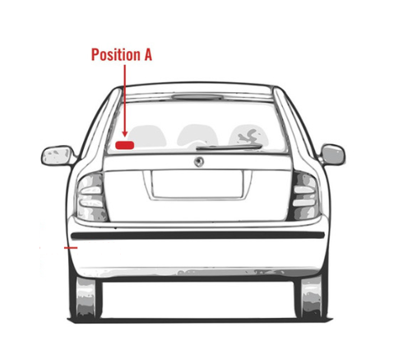
Individuals or vehicles found to be in violation of parking permit policy may be subject to towing [at owners’ expense], ticketing, and or revocation of parking permit.

Denial of Parking Permit:
- Resident does not have valid driver’s license.
- Resident does not own or lease the vehicle.
- Vehicle is not registered in MA.
- There are more registered vehicles than licensed operators.

